200m H DMI/VGA Extender Converter
User Manual V1.0
Special Notification
Before using this product, please read this manual carefully. Please keep this manual for future reference.
The company may change the fuction of product without notice.
Overview
Using a single CAT5e/6 UTP cable, this transmitter can extend HDMI signal up to 200 meters, supports HDMI/VGA loop out, 3.5mm audio extraction on both TX and RX sides. Compliance with standard TCP/IP protocol, supports one sender to multi receivers via switch. With remarkable ability of video processing and transmission, this device makes signal more smooth and stable, it is a cost-effective long distance HDMI signal extend method.
Features
- Standard TCP/IP protocol, TX to multi RX;
- Max resolution 1080P @60Hz;
- Local unit has HDMI/VGA loop out, analog audio extraction;
- Remote unit has both HDMI/VGA outputs, and audio;
- Built-in ESD protection circuit;
- Max2.00m.TX to RX;
- Built'-in PoE (optional).
Tips: suggest to be used with good quality CAT5e/6 UTP cable.
( To prevail in kind )

I/O Description

TX
RX
Mg=  l®)  NOl |  | ^{4W-41.4}  ^{IT}L^{I1}7.1  onpai | i ⁰¹
 | T VIE a c....--.)
,-,-,
V. HMI
ei c5 0 0
(2)
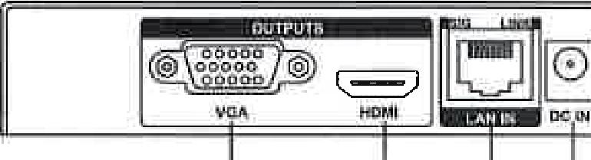
C)HDMI: HDMI signal input © VGA: VGA signal output
© HDMI: HDMI signal output
® LAN OUT: RJ45 port for connecting to CAT5e/6 UTP cable © DC IN: power in (12V DC adapter)
©Ground line
© Power: power on indicator
03.5mm PC audio jack (analog audio output)

Connection Diagram
1. TX to RX: using single CAT6 UTP cable max 200m

2. TX to Multi RX: via switch

STANDARD LENO/FIIIADMI CABLE
412
1080P UP TG2091:rh OF 16CA621 auul
STANDARD
1
LENGTH HDMI CABLE

Tannin./
STANDARD
LENGTH HDMI
CABLE
STANDARD
LENGTH HDMI
CABLE
STANDARD
17 LENGTH HDMI CABLE
STANDARD LENGTH HOW CABLE
HDMI source
1080P UP TO 100m OF Switch/Router
CAT6 CARL (G AWG)
Rurrsiall
1080P UP TO 100m OF
CATE CABLEC29 AVM)-₎
1080P UP TO 10Dm OF
Cps wasp ANC)
RawluaYr |  |  | 1080P UP TO 100m OF  CATO CAOLV23 .1000S

Specifications
Input Video Resolution 60Hz, 720x480, 800x600, 1024x768,
1280x720, 1280x1024, 1366x768, 1440x900, 1600x900, 1600x1200, 1680x1050, 1920x1080
Output Video Resolution - 60Hz, 720P, 1080P
Transmission protocol -TCP/IP
Max transmission bandwidth 225MHz
Max transmission rate 6.75 Gbps (2.5 Gbps per color)
Max transmission distance —TX to RX 200m
Max video cable length < 10m @ 1080P
AV input HDMI signal
AV output HDMI/VGA/audio
Stereo analog 3.5mm audio jack
VGA port VGA-F
Max working currency 450MA

Power adapter spec ---DC 12V/1A
POE- 802.3af (optional)
Working Temperature 5-40°C
Working Humidity range 5-85%RH (none-condensation)
TX dimension- 140x74.5x25(mm)
TX weight 260g
RX dimension 140x74.5x25(m m)
RX weight --260g
Packing List
NO. | Name | Qty | Remark
1 | 200m HDM I/VGA extender(TX & RX) | 1SET
2 | Power adapter | 2PC
3 | User manual _ | 1PC

The matters needing attention of installation
In order to ensure the reliable performance of the equipment and the safety of the user, please observe the following matters during the process of installation, use and maintenance.
- Please do not use this product in the following places: the place of dust, soot and electric conductivity dust, corrosive gas, combustible gas; the place exposed to high temperature, condensation,wind and rain; the occasion of vibration and impact. Electric shock, fire, wrong operation can lead to damage and deterioration to the product, either;
- Should avoid wiring and inserting cable plug in charged state, otherwise it is easy to cause the shock, or electrical damage;
- The installation and wiring should be strong andreliable, contact undesirable may lead to false action;
- This product grounds by the grounding wires. To avoid electric shocks, grounding wires and the earth must be linked together. Before the connection of input or output terminal, please make sure this product is correctly grounded;
- Only after cutting down all external power source, can install, wiring operation begin, or it may cause electric shock or equipment damage;
- Please do not dismantle the equipment, avoid damaging the internal electrical component.

